**Lab Report**

Course Name : Electrical Circuits

Course Code : CSE209 LAB

Section No : 04

Experiment NO : 06

Experiment name : To verify the Thevenin’s theorem theoretically, experimentally, and using PSpice simulation.

**Submitted to**

Course instructor : Rashedul Amin Tuhin

Senior lecturer

Computer science and engineering

**Submitted by**

Name: Apurba Roy Ajay

Student’s ID : 2018-3-60-063

Department : Computer science and engineering

**Date of report submission : /09/2020**

**Objective**: To verify the Thevenin’s theorem theoretically, experimentally, and using PSpice simulation.

**Circuits:**

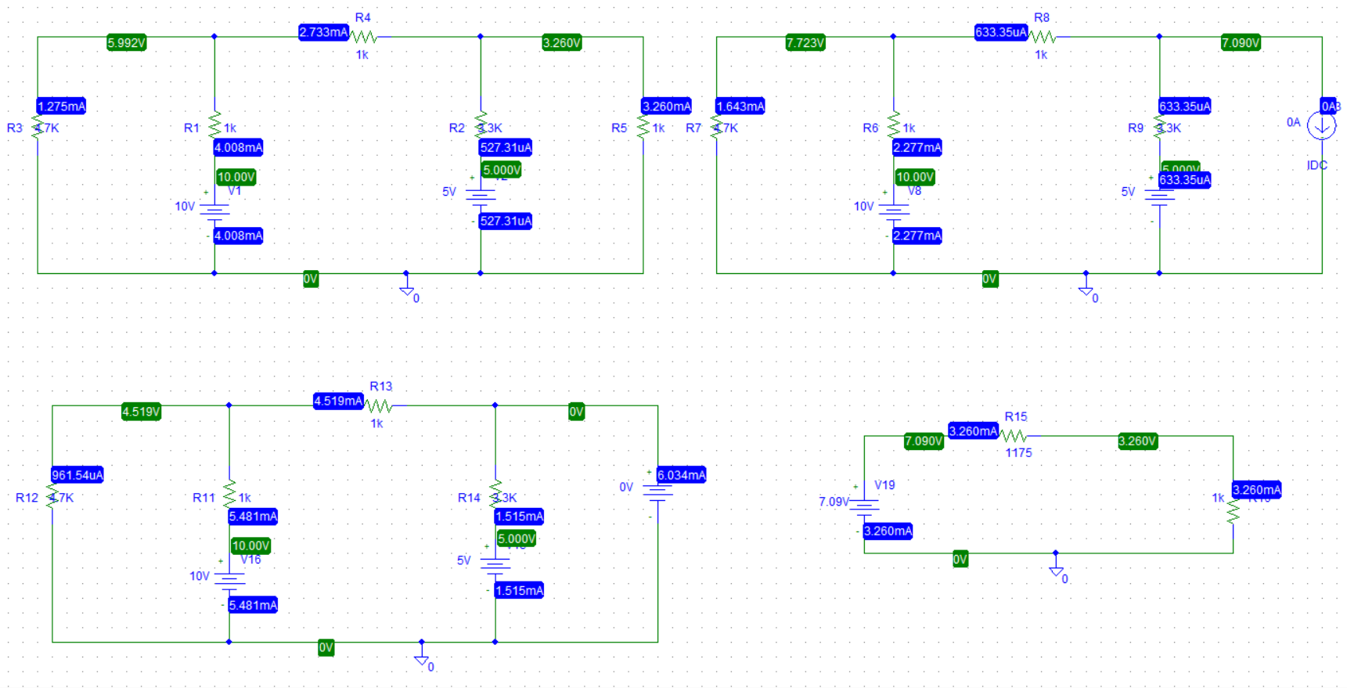

**Table 1.** Experimental Datasheet for determiningThevenin’s equivalent circuit.

|  |  |  |  |  |  |  |  |  |  |  |  |  |  |  |  |
| --- | --- | --- | --- | --- | --- | --- | --- | --- | --- | --- | --- | --- | --- | --- | --- |
| Measured | |  | Measured | | Measured | | | Measured | Measured | | Measured | Measured | | |  |
| Value of *E*1 | |  | Value of *E*2 | | Value | of | | Value of *I*L | value | of | value of *I*SC | Values of | | |  |
|  | |  |  | |  |  | |  |  |  |  |  | | |  |
|  |  |  |  |  | *V*L |  |  |  | *V*OC |  |  | resistors | | |  |
|  |  |  |  |  |  |  |  |  |  |  |  |
|  |  |  |  |  |  |  |  |  |  |  | R1= 1 kR2= 3.3 k R3=4.7 k R4=1 kRL=1 k $Ω$ |
|  |  |  |  |  |  |  |  |  |  |  |  |
| 10 V |  |  | 5 V |  | 3.26mA |  |  | 3.26mA | 7.09V |  | 6.034mA |
|  |  |  |  |  |  |  |  |  |  |  |  |
|  |  |  |  |  |  |  |  |  |  |  |  |
|  |  |  | **Table 2.** Experimental Datasheet forThevenin’s equivalent circuit. | | | | | | | | |  |  |  |  |
|  |  | *E*th= *V*OC | | *R*th= *V*OC/*I*SC | |  | Measured Value of *V*L | | | Measured Value of *I*L | | |  |  |  |
|  |  |  | 7.089V |  | 1.175K Ω |  |  | $3.25$ V |  |  | $3.25$ V |  |  |  |  |

**Answer to the Post-Lab Question.**

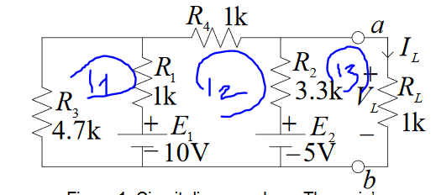  
 Figure:01  
  
  
  
For figure 1,  
Apply KVL at Mest 1,2,3  
(5.7k) $i_{1}$– (1k) $i_{2}$ = -10  
-(1k) $i_{1}$ +(5.3k) $i_{2}$– (3.3k) $i_{3}$ = 10-5

-(3.3k) + (4.3k)i3=5

By calculating this equation ,

$i_{3}$ =3.26 mA

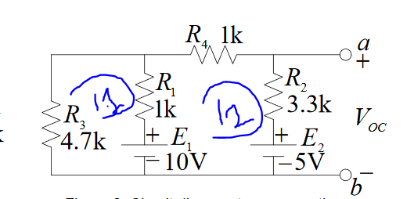  
 Figure: 2

For figure 2,

Here, $V_{oc}$ 
 = (3.3k) $i_{2}$ + 5 = $E_{th}$ $E_{th}$ 
 = 7.089V

Apply KVL at Mest 1,2,  
(5.7k) $i_{1}$– (1k) $i_{2}$ = -10  
-(1k) $i_{1}$ +(5.3k) $i_{2}$ = 5

By calculating this equation ,

$i_{2}$ =0.633mA

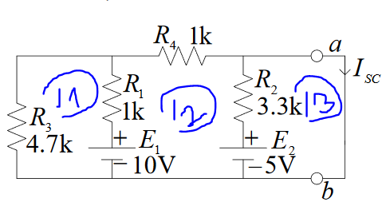  
 Figure: 3

For figure 3,

Here, $I_{sc}$ 
 = $i_{3}$ = 6.034mA

Apply KVL at Mest 1,2,  
(5.7k) $i_{1}$– (1k) $i_{2}$ = -10  
(-1k) $i_{1}$ +(5.3k) $i_{2}$- (3.3k) $i_{3}$ = 10 – 5  
-(3.3k) $i_{2}$ + (3.3k) $i_{3}$ = 5

By calculating this equation , $i_{3}$ 
 = 6.034mA

Now, $R_{th}$ 
 = $V_{oc}$/ $I_{sc}$ = 7.089/6.034m

=1174.843Ω

=1.175K Ω

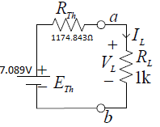  
 Figure: 4

From figure 4,

We know,

$E_{th}$ = 7.089V

So,

$I_{L}$ = 7.089/2.175k A

= 0.00325A

=3.25mA

$V_{L}=3.25 ×1=3.25$ V

$V_{L}$ = 3.25V and $I_{L}$ = 3.25mA

(Thevenin’s theorem verified)

**2.answer:**  
Theoretically calculated values are

$V_{L}$ = 3.25V, $I_{L}$ = 3.25mA, $V_{oc}$ = 7.089V, $I_{sc}$ = 6.034mA, $E_{th}$  
= 7.089V, $R_{th}$ = 1.175K Ω   
  
Measured values are are

$V_{L}$ = 3.25V, $I_{L}$ = 3.25mA, $V_{oc}$ = 7.089V, $I_{sc}$ = 6.034mA, $E_{th}$ = 7.089V, $R_{th}$  
= 1.175K Ω

**3.answer:**

I got everyone’s accurate value when I made this circuit through the PsPice .Then I can’t find any difference of calculate value and measure value

**Conclusion:** We connect this circuit using Pspice software.I think if we could do this same experiment in the lab, the measure value would change a little bit and most importantly we could learn how to connect the circuit for real life.